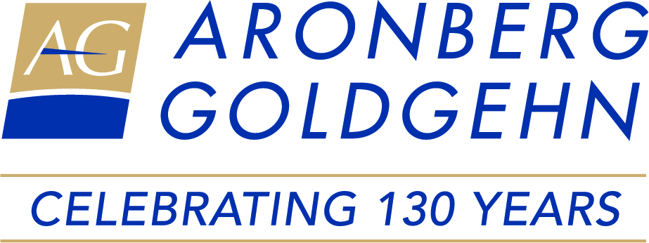

**25 Hot Marketing Tips for Law Firms and International Legal Networks –** *Ross Fishman, Fishman Marketing*

*Don’t you hate programs where you pick up just one or two useful tips? How about 25 powerful, practical ideas, packed into 60 minutes?*

*In this fun and fast-paced presentation, Ross will blast through a hot tip every minute or two for an entire hour, on an eclectic collection of important topics, spanning the full range of ethical and effective marketing and business-development activities, from personal branding and drafting a persuasive LinkedIn profile to public relations and ChatGPT, all within the framework of the profession’s ethics rules. Additional topics covered could include networking, websites, branding, differentiation, online marketing, how to stand out at LNA, and dozens more.*

*Most tips are illustrated with powerful visuals – entertaining examples of terrific and terrible marketing from real-life law firms worldwide.*

**Panel Discussion: Practical Use of A.I. for Attorneys** – Ross Fishman, Fishman Marketing (Moderator), Jayne Reardon, Fisher Broyles, Trisha Rich, Holland & Knight, Gonçalo Areia, RBMS

*The Panel Discussion will begin with a brief overview of how attorneys can use A.I. in their daily practice. The Panel will then discuss their experience and recommendations for practical and ethically compliant use of A.I. tools.*

**Keynote Address –** *The Honorable Lori E. Lightfoot, Former Mayor of Chicago, Charles River Associates, Pritzker Fellow at the University of Chicago Institute of Politics, Fellow at Harvard T.H. Chan School of Public Health*

*Former Mayor Lori E. Lightfoot will discuss her legal career, her transition to the public sector and politics, her time as Mayor of Chicago, and her post-mayoral academic and business career.*

**Talent Tightrope: Balancing Performance & Experiences to Build Tomorrow's Law Firm Today -** *Toby Stansell, NxTrek, Greenville, South Carolina*

*The numbers don’t lie. But the numbers don’t tell the whole story. The World Economic Forum predicts that today’s worker will hold on average 12 jobs throughout their working lifetime. The data supports the hypothesis that they will work for a similar number of different companies, as well. This equates to less than 4 years tenure on average in any particular role or organization. How do we change that? How do we tap into the mindset of today’s developing professional to attract, secure, keep, and inspire those individuals that are ultimately going to set the direction and pace of our firms and help us establish and maintain a competitive edge?*

**Global Trade in 2025: Navigating the Uncertainties**

*Lawrence Friedman, Attorney, Barnes/Richardson Global Trade Law, Marco Padovan, Attorney, Studio Legale Padovan*

*Our presenters will discuss the current state of global trade and the impact of the Trump Administration’s policies on tariffs, sanctions and other trade restrictions. We will hear both the U.S. and European perspectives on how businesses and their attorneys are navigating and adapting to the uncertainties and challenges in the global market.*

**Juneteenth: Legal Lessons from America’s Second Independence Day** *Perri L. Irmer, CEO, The DuSable Black History Museum and Education Center*

*Perri Irmer will explain the historical context of Juneteenth and its establishment as a U.S. federal holiday. The presentation will include an examination of the origins of slavery in the U.S., the abolition of slavery, and the emancipation of enslaved people in the U.S. The perspectives of our attendees is encouraged and welcomed during the question and answer portion of the presentation.*

**Panel Discussion: The Next Generation of LNA** *Marein Smits, Attorney, Wintertaling, Lisette Oosterveen, Attorney, Wintertaling, Kandis Kovalsky, Attotney, Kang Haggerty*

*Our panelists will share details regarding LNA EU’s Next Wave and LNA Americas’ Young Lawyers Division (YLD) initiatives. The panel will consider how LNA member firms can cultivate the next generation of active membership and leadership within LNA.*

**Member Forum: How Can LNA Serve You**

*Jay Frank, Attorney, Aronberg Goldgehn: The Roots of LNA*

*Moderators for Idea Exchange: Albrecht Prestel, Attorney, Arnecke Sibeth Dabelstein, Tim Nelson, Attorney, Aronberg Goldgehn*

*Jay Frank will start this session with a brief presentation on the roots of LNA. Following Jay’s remarks, this interactive idea exchange encourages members to share their ideas regarding how LNA can best serve its member firms. Topics may include: what LNA members want from the organization, how members can better communicate with each other, and how LNA can grow by continuing to attract new members. Attendees are encouraged to (1) consider this topic throughout their time in Chicago, and (2) share their ideas with Albrecht or Tim prior to this session to allow for an efficient and constructive group discussion.*